TWO PHOTON  
Analysis

Software  
User Guide

Version. Revision : 19.23

Last Update :

Authors : Jackie Schiller, Maria Lavzin ,Adam Hantman, Uri Dubin

**Table of Contents**

1 Main Analysis Flow 5

1.1 Overview 5

1.2 File …. 5

1.2.1 Overview 5

1.2.2 Session … 6

1.2.3 Experiment Behavior… 6

1.2.4 Experiment Electro Phys… 8

1.2.5 Import … 8

1.2.6 Close/ Arrange Windows 11

1.2.7 Export … 11

1.2.8 Save All & Exit … 11

1.3 Behavior …. 12

1.3.1 Overview 12

1.3.2 Set Trial Number 12

1.3.3 Config Data 12

1.3.4 Load Trial Data… 13

1.3.5 View XY… 13

1.3.6 View YT… 14

1.3.7 Next Trial Load and Show 15

1.3.8 Events… 15

1.3.9 Event Classifier… 16

1.4 Two Photon …. 16

1.4.1 Overview 16

1.4.2 Set Trial Number 16

1.4.3 Config Data 16

1.4.4 Load Trial Data… 17

1.4.5 View XY… 17

1.4.6 View YT… 22

1.4.7 Next Trial Load and Show… 23

1.4.8 Registration… 23

1.4.9 ROIs… 25

1.4.10 Analysis… 25

1.4.11 ROI Event Detector 30

1.5 Multi Trial … 33

1.5.1 Overview 33

1.5.2 Batch TwoPhoton Registration for all Trials 34

1.5.3 Batch ROI Alignment 35

1.5.4 Batch dF/F all Trials : Fbl = Aver ... 35

1.5.5 Batch dF/F all Trials : Fbl = 10% Min... 36

1.5.6 Batch dF/F all Trials : Fbl = 10% Min Cont... 36

1.5.7 Preview All Trials 36

1.5.8 Multi Trial Explorer 37

1.5.9 Multi Trial Explorer for JAABA Excel 42

1.5.10 Active ROI Per Event Analysis 44

1.5.11 Early/Late ROI Per Event Analysis 45

1.5.12 dF/F Spike Delay Map 47

1.5.13 Batch dF/F Event Detection 47

1.5.14 Batch Behavior Compress 50

1.5.15 Batch Event Assignment 50

1.6 Multi-Experiment … 51

1.6.1 Overview 51

1.6.2 Multi-Experiment Explorer 51

1.7 ElectroPhys.. 51

1.7.1 Overview. 51

2 How To… 52

2.1 Prepare Directory Structure (Old stayle) 52

2.2 Configure the names of the events 52

2.3 Extract registration data per image 53

2.4 Perform Multi Trail Image Registration, ROI Assignment and dF/F Computation 54

2.5 Perform Behavior Event Automatic Classification 54

2.6 Setup JAABA to create feature directories 54

3 Algorithms 55

3.1 Overview 55

3.2 Behavior Event Detection and Classification 55

3.3 Two Photon Image Data Registration 55

3.4 Two Photon Automatic ROI Detection 55

3.5 Two Photon trace conversion to discrete spikes/events 55

4 Data Structures and Interfaces 56

4.1 Overview 56

4.2 Multi Trial Explorer 56

4.3 Multi Group Explorer 57

4.4 SW Directories 59

5 Revision History 60

**List of Figures**

Figure 1 : Main Menu 6

Figure 2 : Data management GUI - add/delete files to/from experiment 9

Figure 3 : Jaaba data folders 10

Figure 4 : Jaaba import results 11

Figure 5 : Preview created data after Jaaba import 11

Figure 6 : Excel interface for Jaaba daat import 12

Figure 7 : Behavior Config Data menu 13

Figure 8 : Behavior XY editor 15

Figure 9: Behavior YT viewer 16

Figure 10 : Behavior Config Data menu 18

Figure 11 : Two Photon ROI Editor Command Options 19

Figure 12 : ROI Editing 21

Figure 13 : ROI aligned tool for different experiments 23

Figure 14 : Two Photon YT editor 24

Figure 15 : Mean fluorescence image rows according to ROI type 27

Figure 16 : Artifact removal example 28

Figure 17 : Fluorescence and Baseline for specific trial 30

Figure 18 : dF/F for ROIs in specific trial 31

Figure 19 : ROI event Auto Detection results 33

Figure 20 : Overlay of ROI Events on dF/F image 34

Figure 21 : Within and Between trial image registration process 35

Figure 22 : Intermediate dF/F results 36

Figure 23 : Multi Trial Explorer – show Traces and Events per Trial 38

Figure 24 : Multi Trial Explorer - Traces per ROI and Event 40

Figure 25 : Multi Trial Explorer - Multiple selection in Trial list is supported 41

Figure 26 : Multi Trial Explorer - Traces Aligned per Event, ROIs & Trials 42

Figure 27 : Multi Trial Explorer two photon events 43

Figure 28 : Multi Trial Explorer for JAABA Excel File 44

Figure 29 : Event Query generation window 45

Figure 30 : Most Active ROI traces 46

Figure 31 : Late response ROI traces 47

Figure 32 : Print of the Early/Late analysis 48

Figure 33 : Width - Peak scatter diagram with cross probing of the events 49

Figure 34 : Event width distribution histogram 50

Figure 35 : Event energy distribution 50

Figure 36 : Width - Peak shift distribution with cross probing enabled 51

Figure 37 : Batch event creation 52

Figure 38 : How to define event 54

Figure 39 : Analysis Flow for Multi-Trial Explorer 57

Figure 40 : Muti Group Analysis 59

Figure 41 : Directories description 60

**List of Tables**

Table 1 : An example of the data directory file 7

Table 2 : Two Photon ROI Object Properties and Methods 57

Table 3 : Behavioral Events Object Properties and Methods 58

Table 4 : Group Object Properties and Methods 59

**List of Abbreviations**

TBD - To Be Defined

**Acknowledgements:**

Special thanks for debugging - Jackie Schiller, Maria Lavzin, Lira Garion, Adam Hatntman

Code contribution from:

1. Piotr Dollar toolbox for automatic classification of events.
2. Image registration - Janelia code originally written by Sun Wenzhi

# Main Analysis Flow

## Overview

To start the software open the TPA_MainGUI.m file in MATLAB and run it. The following window should appear:

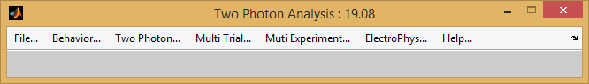

Figure : Main Menu

We develop Two Photon Analysis software that integrates outputs of behavioral, two photon imaging and experiment semantic information. Unanesthetized animal has been trained to perform a food grasping motor tasks. In the same time the calcium imaging activity is monitored in M1 motor cortex using Two Photon laser microscope. This behavioral activity is recorded on video at highest frame rate.

Behavioral motion data is semi-automatically extracted using JAABA. Two Photon image data contains calcium activity of the neuron cells is manually labeled and synchronized with behavioral information.

This software provides a tool to explore behavioral and cell activity patterns on multiple levels.

Each menu item contains multiple functionality and analysis options that will be described next.

## File ….

### Overview

File menu is used to manage data import and save methods. The options are:

* Session : Management of the parameters related to the directory of current experiment.
* Experiment Behavior: Defines options to manage experiment
  + Create New Data Management File – creates new Excel file with all data for analysis.
  + Load Data Management File – loads Excel file with all data for analysis.
  + Save Data Management File - Saves the analysis data structures to Excel
  + Select Directory (Old Style) – select folder which contains experiment data.
  + Check Data Structure: checks and shows data content of the experiment.
  + Preview Data Management Excel File – shows excel file with all data for analysis
* Experiment ElectroPhys: Defines options to manage electro physiology experiments
  + Select Directory – select folder which contains experiment data.
  + New/Clear will reset counters of the ROI regions. Should be done only once.
  + Save Experiment : Saves the analysis to the folder of the experiment
  + Check Data Sync: checks and shows data content of the experiment.
* Close Windows will close all the windows related to this app.
* Arrange Windows will put Behavioral and Two Photon editors in certain positions on the screen.
* Import :
  + Jaaba Directory Score Data – transform Jaaba event detection to BDA_XXXX.mat files for each trial.
  + Jaaba Excel Data (Old)– transform Jaaba excel file to BDA_XXXX.mat files for each trial.

The format of the Excel has special structure outlined in the next Section.

* + Jaaba Excel Data – semi auto
* Export : Only one option : Export current image file to tif. Useful for testing registration quality.
  + Two Photon Image Data to TIF – exports two photon data from any format to tif file.
* Save & Exit : saves the data to the experiment folder and exits

The detailed description of the methods is the following.

### Session …

TBD

### Experiment Behavior…

#### Create New Data Management File…

This option creates excel file that contains description of all the data files required for the experiment including their path information. An example is outlined below

Table : An example of the data directory file



The file " TPC_ExperimentDataDir.xlsx" is saved in the Analysis directory (an example Analysis\M2\10-02-03).

#### Load Data Management File…

Loads the file above and searches for the data in the relevant locations. The information is printed in Matlab window.

#### Refresh Data Management File…

Compares content of the data management file with content of directories. Updates the content of the files if there are some new files / deleted files in the directories pointed by excel directories.

#### Save Data Management File…

Saves the file above in the current Analysis directory.

#### Preview Data Management File…

Opens and shows current Excel file info.

#### Select Directory (Old Style)

This options selects Janelia data. Navigate to the desired folder (Analysis\M2\10-02-03) and select a it. Matlab prints:

No data is loaded at this time.

E : Experiment : Can not load file C:\Uri\Data\Movies\Janelia\Imaging\M2\2_20_14\TPC_Experiment.mat

I : TwoPhoton : data has been read successfully

I : TwoPhoton : Analysis data has been read successfully

I : Behavior side data with 8 frames has been read successfully

I : Behavior front data with 8 frames has been read successfully

I : Behavior : Analysis data has been read successfully

I : TwoPhoton : Using image data from file 2_20_14_m2__001.tif.

I : TwoPhoton : Using analysis ROI data from file TPA_2_20_14_m2__001.mat.

W : TwoPhoton : Video and Analysis file number miss match.

I : Check : Status 1 : Found 8 valid trials.

#### Check Data Sync …

Opens a window that can be used for data file management

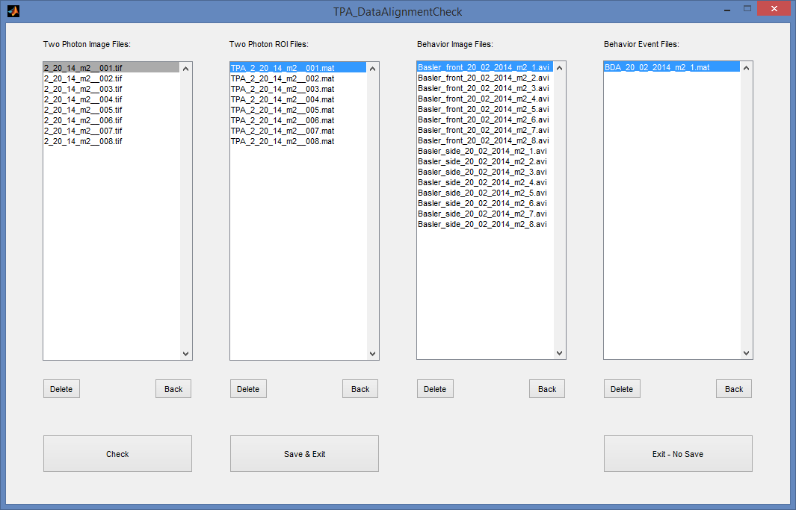

Figure : Data management GUI - add/delete files to/from experiment

Description:

1. In each column shows data files to be used in the experiment.
2. This list could be corrected by deleting files that are not related or are not in sync with the rest.

### Experiment Electro Phys…

#### New/Clear

This option clear all the data related to the experiment and resets ROI counters.

#### Save

Saves the experiment information – ROI counters.

#### Check Data Sync …

Opens a window as in Figure 2 that can be used for data file management and check.

### Import …

#### Jaaba Analysis Data …

Import behavioral events from JAABA SW.

The steps are:

1. First select the experiment : File -> Experiment -> Select Directory …
2. In the selected Video directory should be located Jaaba folders (see example Figure below)  
   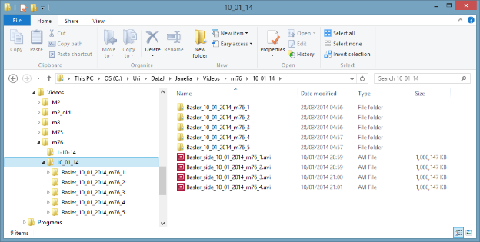

Figure : Jaaba data folders

1. Select the top folder that contains Video files (m76/10_01_14 in the example above).
2. After confirmation that all previous behavior data will be lost Matlab window will print the info like this

I : Jaaba : 9 classifier data files have been loaded from C:\Uri\DataJ\Janelia\Videos\m76\10_01_14\Basler_10_01_2014_m76_4

W : Jaaba : No Events of type Grabm76 - 2 - nothing to convert.

W : Jaaba : Classifier Grabm76 - 2 - something wrong with classification data.

E : Jaaba : Classifier Grabm76 - 2 (8)- can not determine event durations.

I : Jaaba : Converting Jaaba to 9 Events : Done

W : Behavior : Event - No data found. Creating a new file.

I : Behavior : Event data from file BDA_20_02_2014_m2_4.mat has been saved

I : Jaaba : 9 classifier data files have been loaded from C:\Uri\DataJ\Janelia\Videos\m76\10_01_14\Basler_10_01_2014_m76_5

W : Jaaba : Classifier Grabm76 - 1 - something wrong with classification data.

E : Jaaba : Classifier Grabm76 - 1 (8)- can not determine event durations.

I : Jaaba : Converting Jaaba to 9 Events : Done

E : Trial value 5 is out of range. No action taken.

I : Analysis data from file BDA_20_02_2014_m2_4.mat has been loaded successfully

I : Behavior : Event data from file BDA_20_02_2014_m2_4.mat has been saved.

1. Sometimes there short events that are shorter than 10 frames. They will be discarded. The information is printed on the window.
2. The following Analysis data will be created at the end of the process  
   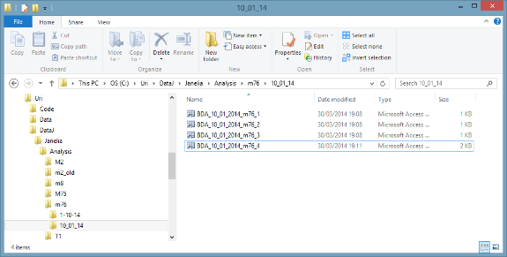

Figure : Jaaba import results

You have only 4 files since the number of video files was only 4.

1. These events now could be viewed and analyzed or manually corrected. You can check your files using command : File ->Check Data Sync…  
   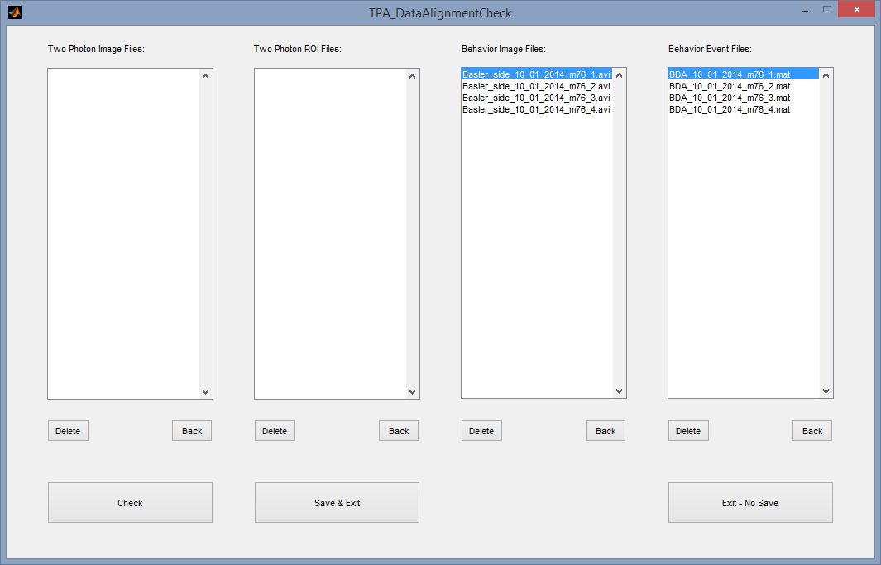

Figure : Preview created data after Jaaba import

#### Jaaba Excel Data …

Import behavioral events from JAABA SW written in Excel File. The format of the Excel must have a structure similar to the outlined below

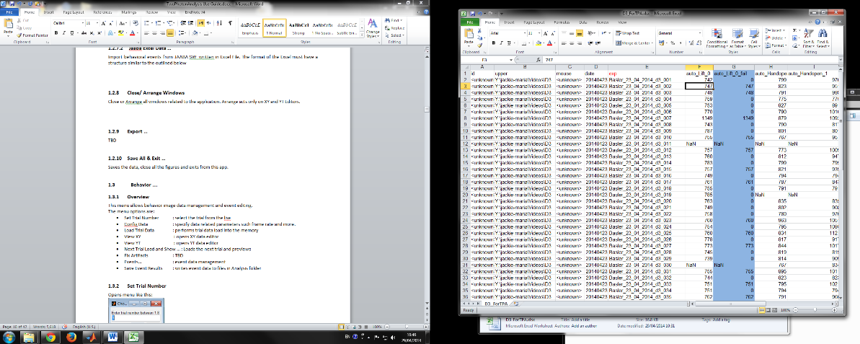

Figure : Excel interface for Jaaba daat import

The first row should be names with special 'exp' column (marked red above). It should be the last column before event columns are presented. The number of event columns is not limited. Each row contains different trial and number designated frame number in trial where the event begins.

### Close/ Arrange Windows

Close or Arrange all windows related to the application. Arrange acts only on XY and YT Editors.

### Export …

TBD

### Save All & Exit …

Saves the data, close all the figures and exits from this app.

## Behavior ….

### Overview

This menu allows behavior image data management and event editing.

The menu options are:

* Set Trial Number : select the trial from the list.
* Config Data : specify data related parameters such frame rate and more.
* Load Trial Data : performs trial data load into the memory
* View XY : opens XY data editor
* View YT : opens YT data editor
* Next Trial Load and Show … : Loads the next trial and previews
* Fix Artifacts : TBD
* Events… : event data management
* Save Event Results : writes event data to files in Analysis folder

### Set Trial Number

Opens menu like this:

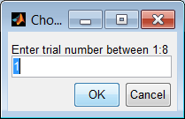

Where you need to select trial to load

### Config Data

Opens menu like this:

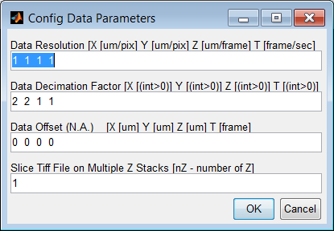

Figure : Behavior Config Data menu

Description:

First row defines resolution parameters in X,Y,Z space. In time, the last parameter is a frame rate. This is important for subsequent view synchronization.

Second row could be used to reduce data memory requirements by decimation.

Third row – offset – TBD

Forth row helps to import data when the Z slices are arranged one after each other in time. Depends on the acquisition equipment.

### Load Trial Data…

Starts data loading of the selected trial. Matlab prints something like this:

I : Behavior : Loading data from file Basler_side_20_02_2014_m2_1.avi. Please Wait ...

W : Behavior : data from file Basler_side_20_02_2014_m2_1.avi is decimated. Check decimation factors

I : Behavior : 2160 images from file Basler_side_20_02_2014_m2_1.avi are loaded successfully

I : Behavior : Loading data from file Basler_front_20_02_2014_m2_1.avi. Please Wait ...

W : Behavior : data from file Basler_front_20_02_2014_m2_1.avi is decimated. Check decimation factors

I : Behavior : 2160 images from file Basler_front_20_02_2014_m2_1.avi are loaded successfully

I : Analysis data from file BDA_20_02_2014_m2_1.mat has been loaded successfully

### View XY…

Opens XY editor

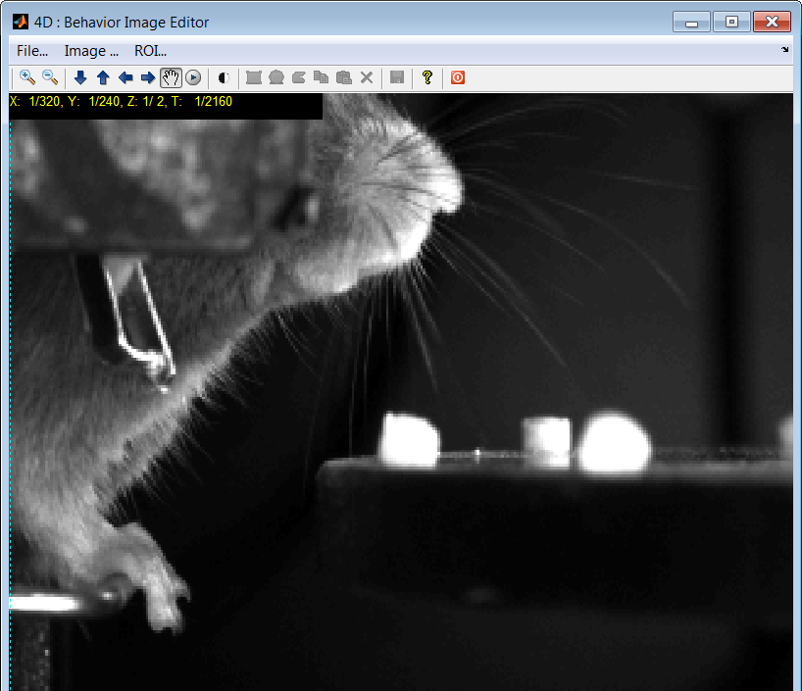

ROI type selection is not implemented

Image View Options

ROI Option

Browse in Z stack

Browse in Time one by one

Browse in Time using Mouse line in Viewer

Contrast Adjustment

Play movie in Viewer

Figure : Behavior XY editor

The user options are:

TBD

### View YT…

Opens YT editor:

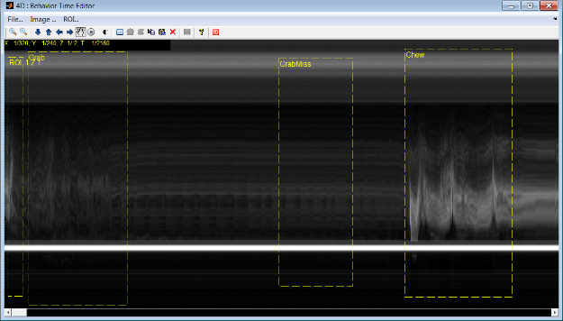

Figure : Behavior YT viewer

The user options are:

1. Select Event names – User Right Click on rectangle -> Rename.  
   The list of names appear in TPA_EventNames.xml located in Setup directory.
2. TBD

### Next Trial Load and Show

This code is a shortcut that executes several commands above. It :

1. Closes all the figures and Saves the current Event data
2. Selects next trial
3. Loads all the Event and Image data
4. Displays the data in two XY and YT Browsers

### Events…

This set of commands supports Event data file management and import into the workspace. The options are:

1. Load From File – import specific BDA_XXX.mat file for this trial image data.
2. New/Clean – deletes all Event info for the current trial.
3. Save and Load – manages file save and load actions. The file name is standard BDA_XXX.mat located in the Analysis directory. For example Save Event prints something like:

I : Behavior : Event data from file BDA_20_02_2014_m2_1.mat has been saved

### Event Classifier…

This set of commands supports automatic Event classification base on image data supplied and some preliminary manual Event marking. It utilizes latest state of the art machine learning tools to detect image parts and certain motions in 3D data.

Classifier options are:

1. Init/Load/Save – manages classifier database and structure over multiple trials
2. Train on Current Trial – trains classifier using event and image data from the current trial. Uses previous classifier info if exists.
3. Train on All Previous Trials – looks up in the directory for all Event data until current trial. Load each of them sequentially. Runs training procedure on Image and Event data.
4. Classify current trial – Uses previous classifier database to find behavioral events in the current image data, loaded previously.

Detailed description of the algorithms involved is given in section ‎3 Algorithms.

## Two Photon ….

### Overview

This Menu allows image management and artifact correction on the Two Photon image data.

The menu options are:

* Set Trial Number : select the trial from the lise
* Config Data : specify data related parameters such frame rate and more.
* Load Trial Data : performs trial data load into the memory
* View XY : opens XY data editor
* View YT : opens YT data editor
* Next Trial Load and Show: close current and load the next trial and show all the data.
* Registration : several methods to align image data
* ROI… : ROI data management
* Analsyis : how to do dF/F computations
* Event/Roi auto detect : commands to explore automatic ROI/Event detection

### Set Trial Number

Opens menu like this:



Where you need to select trial to load

### Config Data

Opens menu like this:



Figure : Behavior Config Data menu

Description:

First row defines resolution parameters in X,Y,Z space. In time, the last parameter is a frame rate. This is important for subsequent view synchronization.

Second row could be used to reduce data memory requirements by decimation.

Third row – offset – TBD

Row number four helps to import data when the Z slices are arranged one after each other in time. Depends on the acquisition equipment.

### Load Trial Data…

Starts data loading of the selected trial. Matlab prints something like this:

I : TwoPhoton : Loading data from file C:\Uri\Data\Movies\Janelia\Imaging\M2\2_20_14\2_20_14_m2__001.tif. Please Wait ...

I : TwoPhoton : 360 images are loaded from file 2_20_14_m2__001.tif successfully

I : TwoPhoton : Analysis data from file TPA_2_20_14_m2__001.mat has been loaded successfully

I : Analysis data from file BDA_20_02_2014_m2_1.mat has been loaded successfully

### View XY…

Opens the following editor

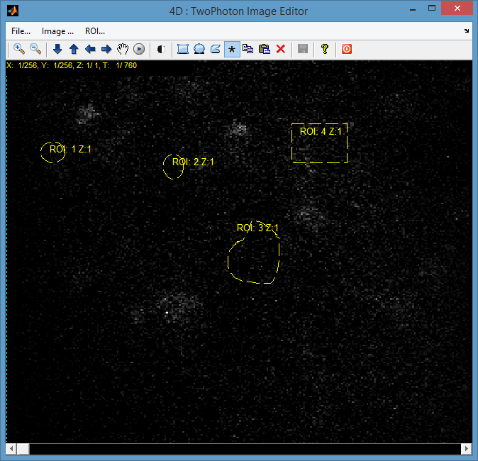

Image menu Options

All ROI Perspective Adjustment

Browse in Z stack

Browse in Time one by one

ROI Option

Browse in Time using Mouse line in Viewer

Play movie in Viewer

Contrast Adjustment

ROI type selection

Figure : Two Photon ROI Editor Command Options

Different buttons have the functionality as depicted on the picture above.

Image menu options allow:

1. Max, Mean, STD, dF/F projection for entire Time and separate Z stack.
2. Default - raw data view.
3. Also compute DFF when *F0* is minimum over all stack and denominator is mean of the stack.

ROI menu options allow:

1. Select ROI by Name – when many ROIs are displayed will show ROI when selected from the list.
2. Copy/Paste - TBD
3. Remove marked ROI – deletes ROI selected.
4. Set Color – change color of the selected ROI
5. Rename – change name – from default
6. Average Type Select – how the averaging is done per ROI data

Button Options are:

1. Zoom In/Zoom Out into the image
2. Browse in Z stack
3. Browse in Time one by one using keyboard arrows
4. Browse in time using mouse navigation line and slider
5. Play image data set. Player will play a movie for fixed period of time. It will skip frames if the movie is too long. To rewind the player press on left size of the image – it will make image movie to jump to the beginning (hand tool must be on).
6. Contrast improvement tool.
7. Draw ROI. You can choose to draw a freehand ROI or an ellipse shaped one by choosing the suitable option in the menu.
8. ROI perspective adjustment tool help align ROIs between different experiments. It may compensate relative 3D alignment of two image planes. It assumes that small rotations and shifts of microscope focal plane relative to the brain are sufficient for recover the alignment.

If you wish to change properties of an ROI, move or rescaled it select the desired ROI by left mouse click:

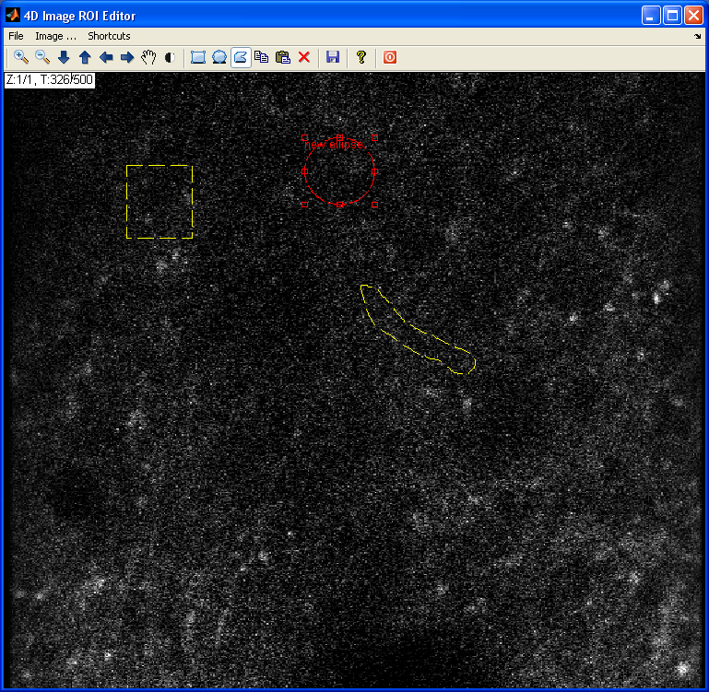

Figure : ROI Editing

You can drug rectangles or move entire ROI according to mouse pointer changes.

To change additional properties of the ROI – right click on the selection rectangle. Context menu appears where you can define:

* + - 1. Name
      2. Color
      3. Delete
      4. Averaging Type
      5. Cell Part Type such as Soma, Apical, Distal, Layer 5 or 2/3.

Choose the averaging type for each ROI a menu will appear asking you to choose the averaging type. Choose and click "OK"

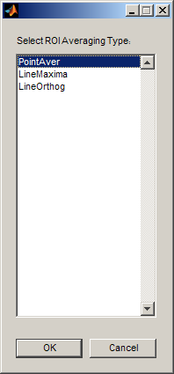

* The default averaging type is PointAver.

In order to align different ROIs between different trials or experiments, there is a possibility to correct the entire set of ROIs by using perspective transformation tool. This tool is outlined on the next Figure

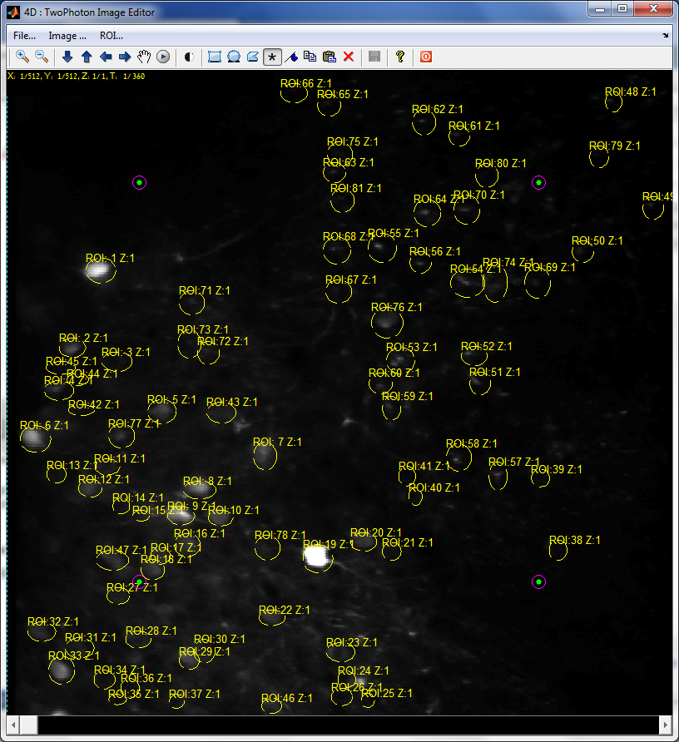

ROI Adjustment Points

Figure : ROI aligned tool for different experiments

The reference points should be grabbed by left mouse click and then dragged to adjust alignment between ROI contours and image data.

### View YT…

Opens YT editor:

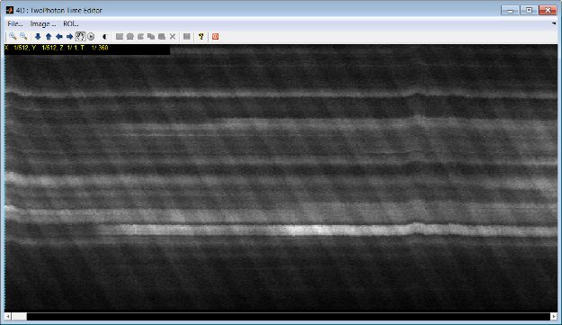

Figure : Two Photon YT editor

The user options are:

1. Move in time (left and right)
2. Select Image projection type : Image Menu -> Type
3. TBD

### Next Trial Load and Show…

This code is a shortcut that executes several commands above. It :

1. Closes all the figures and Saves the current ROI data
2. Selects next trial
3. Loads all the ROI, Motion Shift and Image data
4. Displays the data in two XY and YT Browsers

### Registration…

This option performs motion correction in XY plane using different algorithms.

Matlab window will display:

I : Starting Motion Correction in T. Wait ....

I : Motion Correction Done

After that it is not possible to use the original raw data (Memory considerations). In order to recover the user must load the data once again.

Next we describe several methods used for motion correction/registration.

#### Janelia : Template + Parfor …

This methods requires template specification. It is based on Janelia code originally written by Sun Wenzhi, 8/28/2012 for Image Box SW. This code uses algorithms developed by Ann M. Kowalczyk and James R. Fienup in paper

J.R. Fienup and A.M. Kowalczyk, "Phase retrieval for a complex-valued object by using a low-resolution image," J. Opt. Soc. Am. A 7, 450-458, (1990).

However, sub pixel accuracy is not implemented in this version.

The idea is perform FFT based correlation between two images, one is a target/template reference and other one is the current image data. Maximal value position in correlation image gives the relative shift between two images.

The main problem is usually the selection of the template image. Sun Wenzhi defined the template image as a time average of the images in the selected trial:

Where *I(x,y,t)* image for frame *t* from total *N*.

For the sake of efficiency this code could be parallelized for multiple cores/commuters using *parfor* methods in Matlab.

#### Janelia : Template + FFT …

This methods is the same as previous one but uses Matlab efficient multidimensional FFT command. If there is no possibility to parallelize this job it could provide some time efficiency. It was used in development process.

#### Mtrx Inverse : No Template + FFT …

This methods does not require template specification. The idea is that each image *I[n]* from the stack of *N* images has an unknown shift *xn* that we wish to estimate. However, using Fourier transform correlation we only estimate the differences *yij=dxij=xi-xj*. For entire *N* frame movie we can put this in matrix form

Designating the matrix of *+1* and *-1* by *A* the equation above has the form *Y =*AX. We can solve : *A-1Y=X* to get vector of displacements *X=[x1,x2,…xN]T*. This methods could be evoked by this SW as an option and no template is required.

#### View Results Side by Side

Opens image player with two image frames one before and other after registration.

Use Player ->Tools -> Colormap to adjust color mapping. Usually the numbers are between 0 to 1000.

#### Verify Substitution

User acknowledgement that registration process was OK and corrected image data becomes the current image data. The original raw data is cleared from the memory. In order to return back the raw data use Trial Load menu option again.

### ROIs…

Allows Edit and Draw ROIs on a reference picture or load existing ROIs by going to ROI -> Load ROIs / New ROIs.

The options are:

* Load From File…. : load ROI data from some other location (by default the ROI data is loaded already)
* New/Clean ROIs…. : discards all current ROI data and start from clean the ROI edit GUI
* Save…. : save ROI data to Analysis folder
* Load Current…. : load ROI data from analysis directory

### Analysis…

#### Averaging

The purpose of this menu is to perform and test different averaging options:

* Aver Fluorescence Point ROI : Average all the data to single point
* Aver Fluorescence Line(Max) ROI : TBD
* Aver Fluorescence Line(Orth) ROI : TBD
* Aver Separately by ROI Type : Average data according to ROI type selected previously

Perform averaging on ROIs according to the selected averaging method by going to "Analysis -> Aver Separately by ROI type". You can choose to average all ROIs using one of the methods by choosing the suitable option in the menu.



Figure : Mean fluorescence image rows according to ROI type

#### Artifacts - TBD…

The purpose of this menu is to perform some preprocessing and dF/F computations:

* Remove Artifacts : Smooth Ch1 …
* Remove Artifacts : Decorrelate …
* Remove Artifacts :Bleach & Motion…

Remove artifacts. For experiments where 2 channels were sampled (See " 2Photon_Experiments_Summary" excel file), artifacts may be removed by going to either "Process -> Remove Artifacts : Decorrelate" or "Process -> Remove Artifacts : Bleach & Motion". The difference between the two is explained in the following scheme:

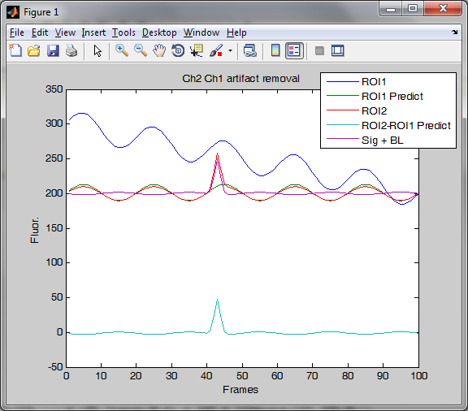

Figure : Artifact removal example

The signal from ch1 is depicted in blue and the signal from ch2 is depicted in red. We assume that oscillations in ch1 are movement artifacts and are in correlation with oscillations in ch2. Ch2 contains both movement artifacts and a Calcium signal. We find a set of parameters (α, β, γ) that determine the relation between the two channels, when we assume that:



By using these parameters we can predict the correlated behavior (assumed movement artifacts) in ch2 by ch1 (depicted in green).

The option "Remove Artifacts :Decorrelate" will subtract the predicted wave from ch2. The result of such an action is depicted in teal. We got rid of most of the movement artifact but we also lowered the baseline to 0, which will affect dF/F calculation and may result in a negative baseline.

The option "Remove Artifacts : Bleach & Motion" will do the same calculation but will add the average value of the predicted wave to the baseline, thus returning to the original baseline values (depicted in pink).

Several windows should appear showing the values for ch2, the predicted values and the difference between them for each ROI.

7.2. Calculate dF/F. Choose either "Process ->dF/F 10% ROIs" or "Process ->dF/Std ROIs".

dF/F 10% ROIs calculates the baseline as the mean of the lowest 10% values for each pixel, subtracts it and divides by the baseline.

dF/Std ROIs calculates the change in fluorescence as , where a value of 2 for example would mean that the fluorescence was 2 standard deviations away from the mean value.

Several windows should appear showing the dF/F for each ROI.

#### dF/F Computations

The purpose of this menu is to perform some preprocessing and dF/F computations.

For each image *I(x,y,t)* with *t = 1..N* time index we compute spatial average for each ROI:

Where *ROIk* designates ROI region *k* selected. *Fk[t]* becomes spatial average fluorescence per time.

Average fluorescence or baseline fluorescence could be computed by 3 options:

1. dF/F : Fbl = Aver Fluorescence :
2. dF/F : Fbl = 10% Min : , *S –* subset of *Fk[t]* with lowest values (10%)
3. dF/F : Fbl = STD : - standard deviation
4. dF/F : Fbl = 10% Min Cont : : – 10% support average filter

The *dF/F* for each ROI is computed as follows:

The following images are displayed after this command:



Figure : Fluorescence and Baseline for specific trial



Figure : dF/F for ROIs in specific trial

### ROI Event Detector

#### Event Auto Detect (dff-1, emph-4)…

The steps of automatic detection are:

1. Compute *dF/F* for each pixel over time using Average Fluorescence formula above. The results is *dFF(x,y,t)* 3D array .
2. Signal emphasizes by computing noise STD for each pixel, averaging and dividing *dFF(x,y,t)/(3*STD)*.
3. Emphasize the results by increasing power of each pixel by factor *EmphPower*:   
   *(dFF(x,y,t)/(3*STD)) EmphPower*  
   the values of *EmphPower = 1*.
4. Compare results with threshold *dffThr = 3*  or *5*.
5. Average again using averaging box filter in *x,y* and *t* size [*5x5x5*]
6. Threshold again using 0.75 threshold
7. Fill small holes in the binary data
8. Label the results

#### Event Auto Detect (dff-1, emph-5)…

The steps of automatic detection are:

1. Compute *dF/F* for each pixel over time using Average Fluorescence formula above. The results is *dFF(x,y,t)* 3D array .
2. Signal emphasizes by computing noise STD for each pixel, averaging and dividing *dFF(x,y,t)/(3*STD)*.
3. Emphasize the results by increasing power of each pixel by factor *EmphPower*:   
   *(dFF(x,y,t)/(3*STD)) EmphPower*  
   the values of *EmphPower = 3*.
4. Compare results with threshold *dffThr = 3*  or *5*.
5. Average again using averaging box filter in *x,y* and *t* size [*5x5x5*]
6. Threshold again using 0.75 threshold
7. Fill small holes in the binary data
8. Label the results

#### Event Auto Detect (dff-1, emph-6)…

The steps of automatic detection are:

1. Compute *dF/F* for each pixel over time using Average Fluorescence formula above. The results is *dFF(x,y,t)* 3D array .
2. Signal emphasizes by computing noise STD for each pixel, averaging and dividing *dFF(x,y,t)/(3*STD)*.
3. Emphasize the results by increasing power of each pixel by factor *EmphPower*:   
   *(dFF(x,y,t)/(3*STD)) EmphPower*  
   the values of *EmphPower = 3*.
4. Median filter the results using spatial median filter size *[3x3]*
5. Compare results with threshold *dffThr = 3*  or *5*.
6. Average again using averaging box filter in *x,y* and *t* size [*5x5x5*]
7. Threshold again using 0.75 threshold
8. Fill small holes in the binary data
9. Label the results

#### Event Auto Detect (dff-11, emph-6)…

The steps of automatic detection are:

1. Compute *dF/F* for each pixel over time using Moving Average Fluorescence. Moving average is comuted using 3,3,30 size filter in Row,Column and Time. The results is *dFF(x,y,t)* 3D array .
2. Signal emphasizes by computing noise STD for each pixel, averaging and dividing *dFF(x,y,t)/(3*STD)*.
3. Emphasize the results by increasing power of each pixel by factor *EmphPower*:   
   *(dFF(x,y,t)/(3*STD)) EmphPower*  
   the values of *EmphPower = 3*.
4. Median filter the results using spatial median filter size *[3x3]*
5. Compare results with threshold *dffThr = 3*  or *5*.
6. Average again using averaging box filter in *x,y* and *t* size [*5x5x5*]
7. Threshold again using 0.75 threshold
8. Fill small holes in the binary data
9. Label the results

The final show could look like this

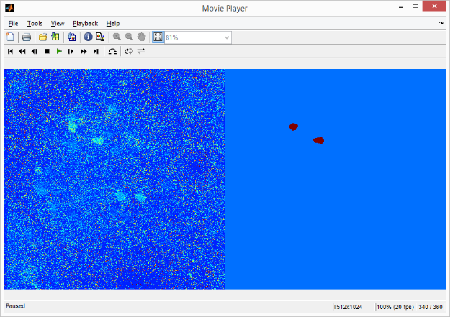

Figure : ROI event Auto Detection results

#### Play dFF + Results…

Simultaneously show computed dF/F for entire image set and segmented regions of activity.

Use Player -> Tools -> Colormap -> Jet(256) and Range [0 to 33]

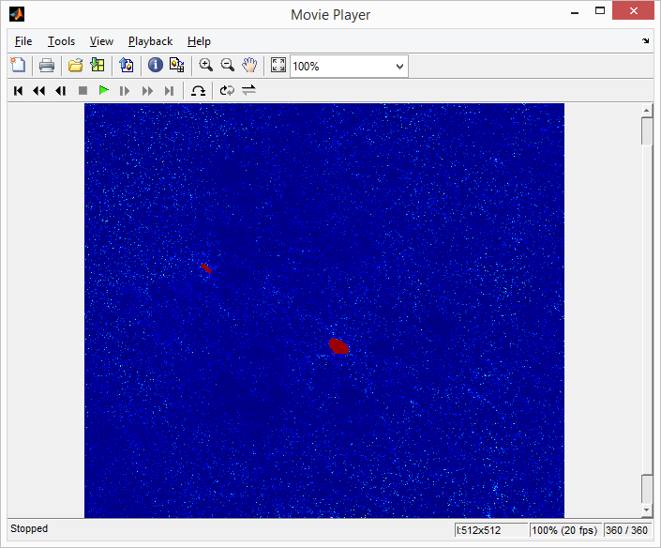

Figure : Overlay of ROI Events on dF/F image

#### Export to ROI…

Extract ROI data from regions of activity found previously, save them to disk in appropriate TPA_XXXX.mat file and also show them on original data using Two Photon viewer XY.

## Multi Trial …

### Overview

This menu allows analysis of all the results from all trials. The options are:

* Batch TwoPhoton Registration for all Trials : registration of all images
* Batch ROI Assignment... : Find all ROIs and copy them to all trials.
* Batch Processing dF/F all Trials... : process all the trial data to compute dF/F
* Preview All Trials… : show dF/F for particular ROI
* Multi Trial Explorer… : opens main dF/F viewer and search engine
* dF/F all ROIs … : Show all ROI data - TBD
* dF/F Event Detection : Make measurements and scatter plots of the events for particular ROI

### Batch TwoPhoton Registration for all Trials

The registration process is:

1. For each trial performs single trial registration using Template algorithm with 3 iterations.
2. Estimate mean image after motion correction
3. Save the correction and the image
4. After single trial registration - perform registration on mean images from all trials. This will generate between trial image motion information.
5. For each trial – load previous motion correction results and add between trial motion.
6. Save the results to TPA_XXX.mat

The process is outlined schematically on the next Figure

Trial 1

Trial 2

Trial N

Raw Data

Within Trial Alignment

Between Trial Alignment

Average 1

Average 2

Average N

Figure : Within and Between trial image registration process

Final image shift is computed by summing Within and Between trial alignment results. For example,

*dXk[n]* is a shift in *X* axis for trial *k* and in image number *n*. It is computed by using following algorithm:

*for k=1:TrialNum , % for each trial*

*dXk[n] = zeros(N,2); % init offsets*

*for m = 1:3*,

*Tk = mean(Ik[1:N]); % average image over n images in trial k*

*[Ik[n], dXtmp[n]] = Registration(Ik[n],Tk); % register and compute corrected image*

*Tav[k] = Tk; % save average image*

*dXk[n] = dXk[n] + dXtmp[n]*; % *add corrections*

*end*

*end*

*% register between trials*

*dXav[k] = zeros(TrialNum,2); % init offsets*

*for m = 1:3*,

*T = mean(Tav [1: TrialNum]);*

*[Tav [k], dXtmp [k]] = Registration(Tav[k], T);*

*dXav[n] = dXav[n] + dXtmp[n]*; % *add corrections*

*end*

*% add between trial correction to the previous one*

*for k=1:TrialNum , % for each trial*

*dXk[n] = dXk[n] + dXav[k]; % offsets with between in intra trial results*

*end*

Al the results are saved to TPA_XXX.mat files in *strShift* array.

### Batch ROI Alignment

This command performs the following actions:

1. Loads all ROIs from all trials.
2. Finds unique ROIs according to names specified.
3. Projects these unique ROIs for all trials.
4. Saves the results to TPA_XXX.mat files – destroys any previous ROI data.

### Batch dF/F all Trials : Fbl = Aver ...

This command performs dF/F computation for each ROI in each trial. It loads image data and adds motion information if registration process has been done before. The computation for each ROI in each trial is done according to dF/F Computations- ‎1.4.10.3.

Will be showing images as below as intermediate results



Figure : Intermediate dF/F results

dF/F details:

* Averaging spatial process : point average
* Averaged Fluorescence : time mean
* Artifact Correction : none
* dF/F Type : mean

dF/F information is saved to TPA_XXXX.mat per trial basis.

### Batch dF/F all Trials : Fbl = 10% Min...

This command performs dF/F computation for each ROI in each trial. It loads image data and adds motion information if registration process has been done before. The computation for each ROI in each trial is done according to dF/F Computations- ‎1.4.10.3.

### Batch dF/F all Trials : Fbl = 10% Min Cont...

This command performs dF/F computation for each ROI in each trial. It loads image data and adds motion information if registration process has been done before. The computation for each ROI in each trial is done according to dF/F Computations- ‎1.4.10.3.

### Preview All Trials

Simple Trial preview for specific ROI. It opens first unique ROI list where user can select an ROI :

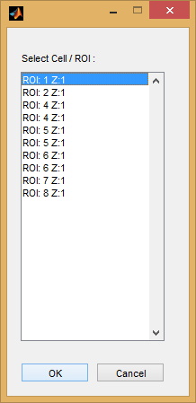

Then ROI Two Photon data with Behavioral information is displayed for all trials. Please note that Behavioral information is aligned to Two Photon. If it is not User need to specify the Frame Rate for behavioral image data : Behavior -> Config Data -> Data Resolution …

### Multi Trial Explorer

#### Overview

Opens the following window:

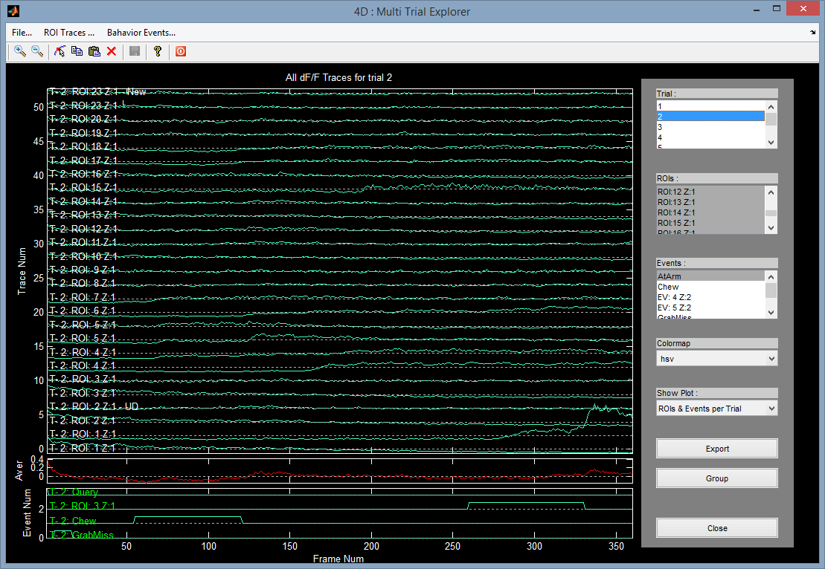

Discrete Events

Toggle Cursors

Export data to Group

Search and Display Type

Select Behavior Events

Select ROIs

Select Trials

Figure : Multi Trial Explorer – show Traces and Events per Trial

Description of the different query and display options:

1. Show all ROI traces in the top axis.
2. Average of all the traces in the middle axis.
3. Events are located on lower axis.
4. Query options are lists from the right side.
5. Show options are located under combo box Show Plot.
6. Colormap changes line colors
7. Export – Export data to Excel
8. Group button – generates group / snapshot of the current view. This structure could be used for subsequent group analysis and comparison.
9. Close - works

ROI Menu:

1. Expand Axis – shows ROI axis in expanded view

Event Menu:

1. Expand Axis – shows Event axis in the expanded view

Toolbar buttons:

1. Toggling and Selection of the coursors
2. Two Photon spike extraction – detects two photon events

Now we describe different queries that could be done using this app

#### ROI Traces and Events per Trial

To show all ROI traces and Events in certain trial:

1. Select -> Show Plot -> ROI and Events.   
   You can select different trials and see how the graphs are changing.
2. ROI List and Event List do not have any effect on display.
3. See Figure 23

#### All Trial Traces per ROI and Event

To see all the traces for all trials related to certain ROI and certain Event:

1. Select -> Show Plot -> Traces per ROI & Event
2. Single selection in ROI list and Event List.
3. Trial selection has no effect
4. See Figure 24

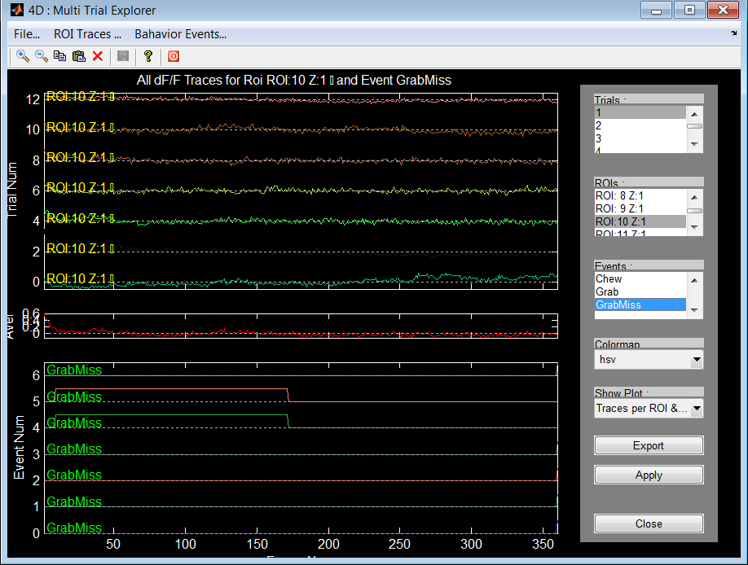

Figure : Multi Trial Explorer - Traces per ROI and Event

#### All Traces per Event, ROIs & Trials

To see all the traces for all trials related to certain Event:

1. Select -> Show Plot -> Traces per Event, ROIs & Trials
2. Single selection in Event List.
3. Multiple selection/filtering in Trial list is supported
4. Multiple selection/filtering in ROI list is supported
5. Data is not aligned per Event time
6. See Figure 25

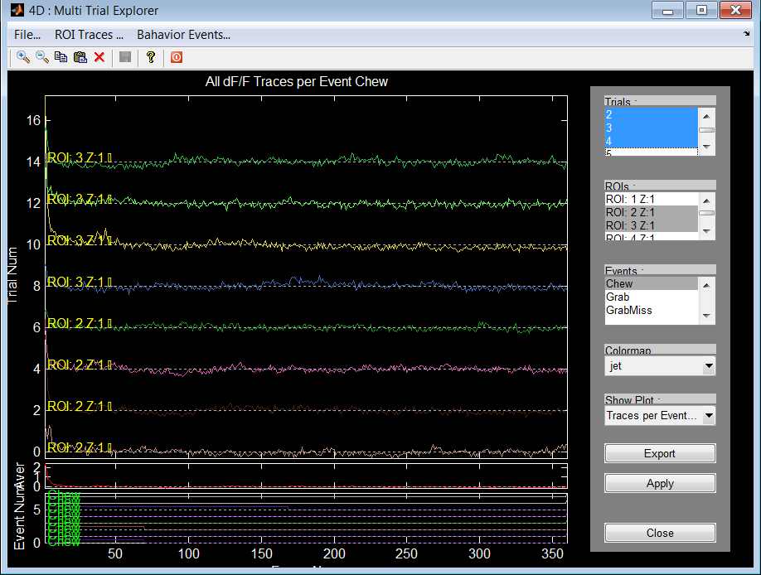

Figure : Multi Trial Explorer - Multiple selection in Trial list is supported

#### All Traces Aligned per Event, ROIs & Trials

To see all the traces for all trials related to certain Event aligned according start time of the event:

1. Select -> Show Plot -> Traces Aligned per Event, ROIs & Trials
2. Single selection in Event List.
3. Multiple selection/filtering in Trial list is supported
4. Multiple selection/filtering in ROI list is supported
5. Data is aligned per FIRST Event start time
6. See the next FigureFigure 25

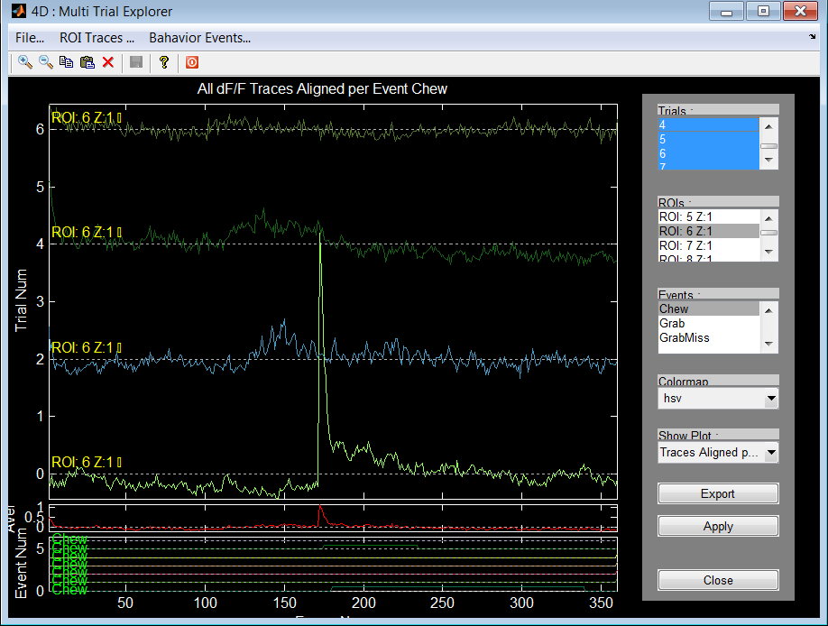

Figure : Multi Trial Explorer - Traces Aligned per Event, ROIs & Trials

Attention : if there are several similar events per trial (for example multiple GrabMiss) the alignment will be according to the first event.

#### All Traces per ROIs

To see all the traces for all trials related to certain ROI without any connection to event data:

1. Select -> Show Plot -> Traces ROIs
2. Single selection in ROI List.
3. Multiple selection/filtering in Trial list is supported

#### Convert Two Photon traces to discrete events

To see all the traces as discrete spike events could be done using special tool build in Multi-Trial Explorer:

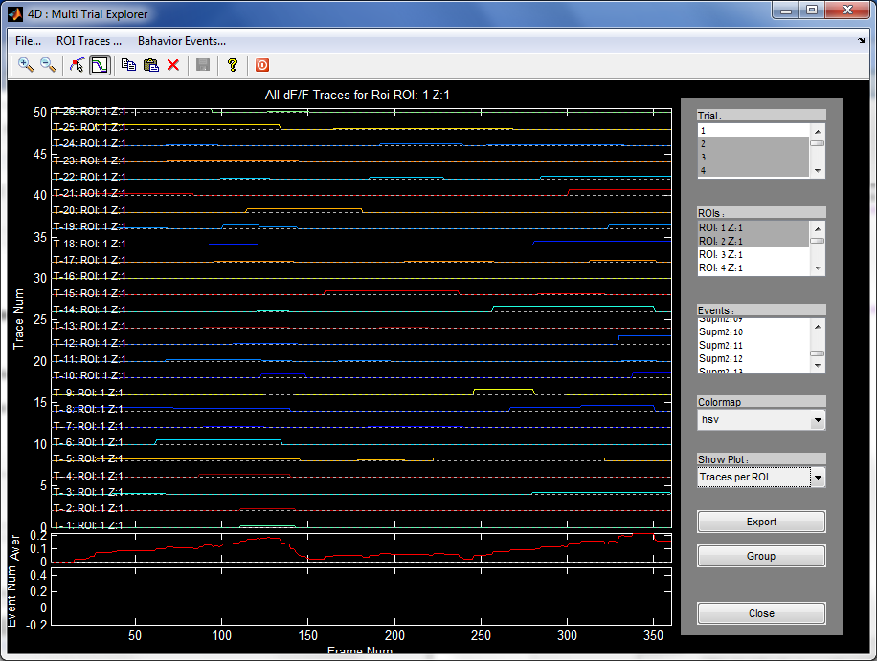

Discrete Events

Figure : Multi Trial Explorer two photon events

Description of the Algorithm for transformation from two photon imaging data to discrete events is outlined in section Algorithms.

### Multi Trial Explorer for JAABA Excel

#### Overview

This type of analysis uses JAABA file to generate events and different queries which are related to the behavioral events.

Opens the following window:

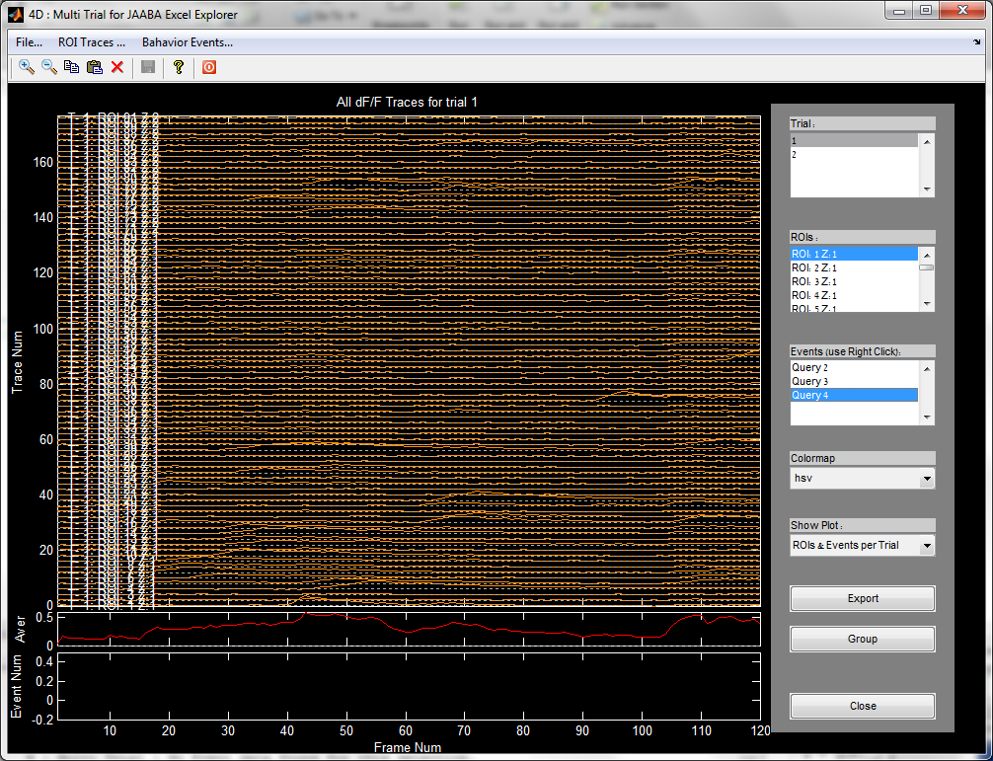

Query List Management

Figure : Multi Trial Explorer for JAABA Excel File

The interface is similar to the previously described Multi Trial Explorer but event management is different. First, it will ask about JAABA excel/csv data, which contains JAABA generated events as column names and rows are trials. Each entry designates in which frame the current behavioral event is found.

Figure above show query list management which is used to create, delete and select JAABA event from Event Editor. Right click on this field opens a menu that allows 3 actions:

1. Add new query – opens Query Editor outlined in the next section
2. Delete query – deletes selected query from the list
3. Rename query – user can change a name of the query

The rest of actions is similar to the Multi-Trial Explorer described in previous section.

#### Query editor

Query editor allows to combine different query options for event post processing. It allows to deal with special event sequences. The interface is outlined below:

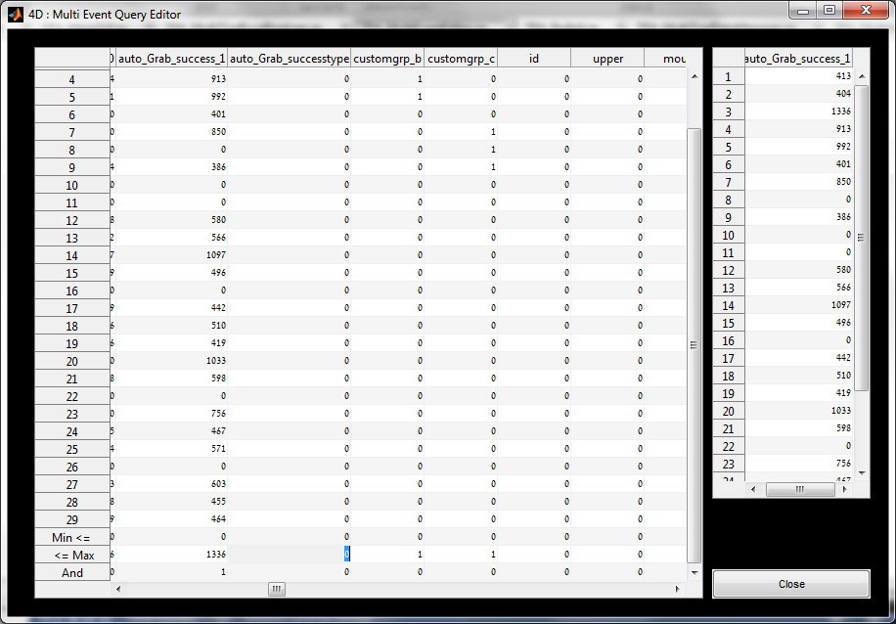

Figure : Event Query generation window

Query editor relies on JAABA output excel file (example can be found in [.\Test\rawtest.csv](Test/rawtest.csv)). In addition it adds 3 rows which allow to generate logical rules between different columns.

How to use event query editor:

* Entries in row ‘Min <=’ and row ‘<=Max’ define range of valid values for each column. User can modify each column valid range separately.
* Entry in the row “And” could be 0 or 1 and designates if the column participates in query generation. Setting 1 in multiple columns will create AND rule between all the ranges and data in these columns.
* The contention between different rules will color the query entries in red.

### Active ROI Per Event Analysis

This tools helps to select the most active ROIs from the total list. It shows 3 the most active ROI's. The output for single ROI could look like below

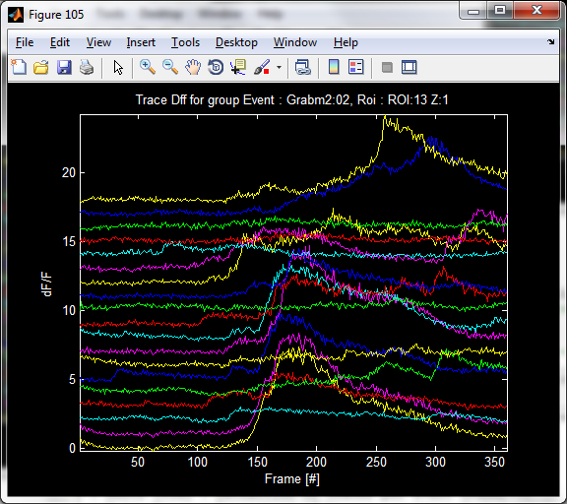

Figure : Most Active ROI traces

### Early/Late ROI Per Event Analysis

Another option is to sort ROI's according to their activity related to some specific event.

For example, late response ROI traces is given below

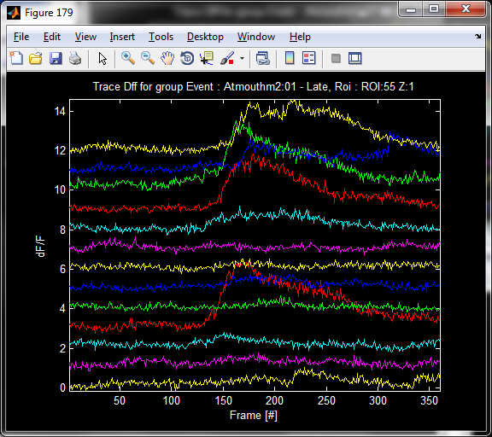

Figure : Late response ROI traces

Also, Matlab window prints the list of the most active ROIs according to Early/On-Time/Late relative to the selected behavioral event.

I : Best 1 : Early : Event : Atmouthm2:01, Roi : ROI:19 Z:1

I : Best 1 : OnTime: Event : Atmouthm2:01, Roi : ROI: 8 Z:1

I : Best 1 : Late : Event : Atmouthm2:01, Roi : ROI:13 Z:1

I : Best 2 : Early : Event : Atmouthm2:01, Roi : ROI: 1 Z:1

I : Best 2 : OnTime: Event : Atmouthm2:01, Roi : ROI:61 Z:1

I : Best 2 : Late : Event : Atmouthm2:01, Roi : ROI:48 Z:1

I : Best 3 : Early : Event : Atmouthm2:01, Roi : ROI: 6 Z:1

I : Best 3 : OnTime: Event : Atmouthm2:01, Roi : ROI: 9 Z:1

I : Best 3 : Late : Event : Atmouthm2:01, Roi : ROI:47 Z:1

I : Best 4 : Early : Event : Atmouthm2:01, Roi : ROI: 9 Z:1

I : Best 4 : OnTime: Event : Atmouthm2:01, Roi : ROI: 6 Z:1

I : Best 4 : Late : Event : Atmouthm2:01, Roi : ROI:23 Z:1

I : Best 5 : Early : Event : Atmouthm2:01, Roi : ROI:16 Z:1

I : Best 5 : OnTime: Event : Atmouthm2:01, Roi : ROI:48 Z:1

I : Best 5 : Late : Event : Atmouthm2:01, Roi : ROI:61 Z:1

I : Best 6 : Early : Event : Atmouthm2:01, Roi : ROI:12 Z:1

I : Best 6 : OnTime: Event : Atmouthm2:01, Roi : ROI:63 Z:1

I : Best 6 : Late : Event : Atmouthm2:01, Roi : ROI:56 Z:1

I : Best 7 : Early : Event : Atmouthm2:01, Roi : ROI: 8 Z:1

I : Best 7 : OnTime: Event : Atmouthm2:01, Roi : ROI:19 Z:1

I : Best 7 : Late : Event : Atmouthm2:01, Roi : ROI:11 Z:1

I : Best 8 : Early : Event : Atmouthm2:01, Roi : ROI:43 Z:1

I : Best 8 : OnTime: Event : Atmouthm2:01, Roi : ROI: 7 Z:1

I : Best 8 : Late : Event : Atmouthm2:01, Roi : ROI:53 Z:1

I : Best 9 : Early : Event : Atmouthm2:01, Roi : ROI: 7 Z:1

I : Best 9 : OnTime: Event : Atmouthm2:01, Roi : ROI: 1 Z:1

I : Best 9 : Late : Event : Atmouthm2:01, Roi : ROI:55 Z:1

Figure : Print of the Early/Late analysis

### dF/F Spike Delay Map

### Batch dF/F Event Detection

This tools finds all the events for particular ROI, performs measurement of duration, peak, area (energy) and peak to center of mass delay and plots different scattering diagrams.

The options are:

* Configure : define detection parameters - TBD
* Detect Events on ROI data …

#### Detect Events on ROI data

Opens the ROI selection GUI :

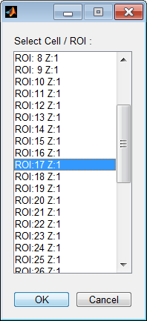

And after selection and OK performs event detection over all trials for particular ROI.

The scattering information is:

 

Figure : Width - Peak scatter diagram with cross probing of the events

The cross probing function allows to review the event shape/raw dF/F data.

Additional information is given by histogram views



Figure : Event width distribution histogram



Figure : Event energy distribution

Energy parameter is computed by:

Where *N* are number of samples in the event structure.



Figure : Width - Peak shift distribution with cross probing enabled

### Batch Behavior Compress

Compress all behavioral files tif to avi format to save space.

### Batch Event Assignment

This option allows to insert constant events that has been present during the trial and not recorded.

For example, Tone or Table rotation.

Selecting this option User gets the following figure

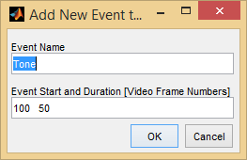

Figure : Batch event creation

Description:

1. User must name this event (usually Tone or Table)
2. Specify start frame number and duration.

After that this event will be added to all event files in all trials.

## Multi-Experiment …

### Overview

In this section we implement different commands to compare results from multiple experiments.

### Multi-Experiment Explorer

TBD

## ElectroPhys..

### Overview.

# How To…

## Prepare Directory Structure (Old stayle)

Three different SW are generating data for single experiment.

We assume that Behavioral data is stored in folder called “Videos”, Two Photon data is located in folder “Imaging” and results of the analysis in folder “Analysis”.

Each folder contains the following structure for experiment:

Videos -> Name of the Animal - > Experiment Day/Code.

Example:

<your path>\Analysis\M2\2_20_14\ mat files

<your path>\Videos\M2\2_20_14\ avi files

<your path>\Imaging\M2\2_20_14\ tif files

## Configure the names of the events

In order to change/add/delete names of the behavioral events you need to edit file “TPA_EventNames.xml” located in Setup folder.

The files looks like :

<?xml version="1.0" encoding="utf-8"?>

<S>

<Grab>1</Grab>

<Chew>2</Chew>

<GrabMiss>3</GrabMiss>

</S>

Add some additional fields according to the pattern above.

Then using Behavioral YT editor, right click on the selected event:

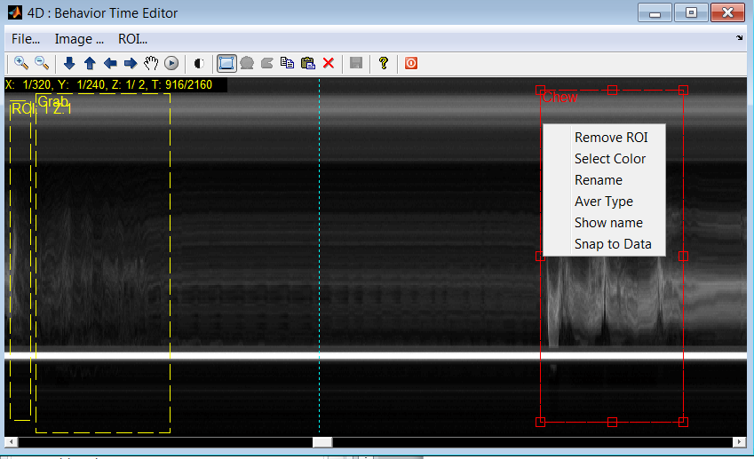

Figure : How to define event

Select Rename, which will bring the following menu:

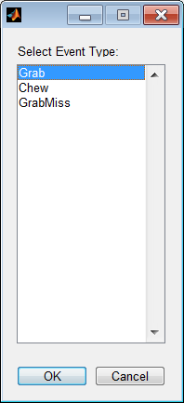

These are the options to select from. They have been defined in the xml configuration file.

## Extract registration data per image

In order to get the registration data from the entire experiment user must to do:

1. Select desired experiment : File -> Experiment -> Select Directory
2. Run : Multi Trial -> Batch Two Photon Registration for all Trials. This will add/update TPA_XXX.mat files in the Analysis directory.
3. Load single TPA_XXX.mat file and you will find two subfield : *strROI* and *strShift*.
4. *strShift*  contains offset information in Y (first column) and X (second column) for particular trial XXX and for each image.

After running batch registration you can you data from each TPA_XXX.mat to apply motion correction.

You can find example how to load image data and offset in the code: *fManageTwoPhoton* function in *MainGUI* or:

% load

[Par.DMT, SData.imTwoPhoton] = Par.DMT.LoadTwoPhotonData(Par.DMT.Trial);

% apply shift

[Par.DMT, strShift] = Par.DMT.LoadAnalysisData(Par.DMT.Trial,'strShift');

[Par.DMT, SData.imTwoPhoton] = Par.DMT.ShiftTwoPhotonData(SData.imTwoPhoton,strShift);

## Perform Multi Trail Image Registration, ROI Assignment and dF/F Computation

In order to process the entire data set you will need to execute the following steps:

1. Clean all the TPA_XXX.mat files from the relevant Analysis directory.
2. Prepare/align image data : Multi Trial -> Batch Two Photon Registration…
3. Mark ROIs on one or more trials : TwoPhoton -> View XY -> …
4. Extend ROI assignment to all trials : Multi Trial -> Batch ROI Assignment …
5. Compute dF/F for all ROIs and trials : Multi Trial -> Batch dF/F …

## Perform Behavior Event Automatic Classification

In order to process and classify the entire Behavioral image data set you will need to execute the following steps:

1. TBD

## Setup JAABA to create feature directories

In order to process and classify the entire Behavioral image data set using JAABA (Version ??? from 08/14) the following steps are required:

1. In Matlab go to directory .. \JAABACode_multi\miceCode
2. Execute : setuppaths
3. For new behavior data we need to create classifier directories, run   
   setUpDir('C:\LabUsers\Uri\Data\Janelia\Videos\M75\2_21_14')
4. Set interesting points as GUI requests (food, mouth, and porch)
5. You should observe that directories are added below the directory specified above
6. It takes a long time to generate feature data – wait

# Algorithms

## Overview

In this section we provide detailed description of the algorithm involved in data analysis.

## Behavior Event Detection and Classification

## Two Photon Image Data Registration

## Two Photon Automatic ROI Detection

## Two Photon trace conversion to discrete spikes/events

# Data Structures and Interfaces

## Overview

In this section we provide detailed description of the analysis data structures and interconnections between them. The current design flow is outlined in the Figure below

Behavior AVIs

Two Photon TIFs

Behav

Event

Edit

TP  
ROIs

Edit

Manual

JAABA

Manual

dF/F

Process

ROI

List

Event

List

Multi  
Trial

Process

&

Explore

BDA_* files

TPA_* files

ROI

List

Figure : Analysis Flow for Multi-Trial Explorer

The additional functionality that is not shown here is the image registration and automatic event extraction from Two Photon data.

## Multi Trial Explorer

Multi Trial explorer has been defined previously and uses two main objects (array of objects) : ROI and Behavioral Events

Table : Two Photon ROI Object Properties and Methods

|  |  |  |  |  |
| --- | --- | --- | --- | --- |
| **P/M** | **Name/Type** | **Description/Rationale** | **Type** | **Note** |
|  |  |  |  |  |
| P | Name | Automatically generated name | String |  |
| P | AverType | Traces Selected by user | String |  |
| P | BoundBox | Bounding box of the ROI in XY plane | Array |  |
| P | xyInd | XY ROI bounding curve in image plane | Array |  |
| P | tInd | Time index for start and end | Array |  |
| P | Ind | Pixel indexes in XY plane inside ROI. | Array |  |
| P | Color | Color of the ROI | string |  |
| P | CellPart | Which cell part it is. Options are SOMA_5','SOMA_23','APICAL_PROXIMAL','APICAL_DISTAL', 'APICAL_TUFT | String |  |
| P | meanROI | Mean fluorescence inside ROI regions | Array |  |
| P | baselineROI | baseline fluorescence inside ROI regions | Array |  |
| P | procROI | dF/F processing result for ROI.  dF/F = (meanROI - baselineROI)./ baselineROI | Array |  |
| P | Graphics Related | Related to ROI drawing | Array Strings |  |
|  |  |  |  |  |

Table : Behavioral Events Object Properties and Methods

|  |  |  |  |  |
| --- | --- | --- | --- | --- |
| **P/M** | **Name/Type** | **Description/Rationale** | **Type** | **Note** |
|  |  |  |  |  |
| P | Name | User Specified name | String |  |
| P | AverType | Traces Selected by user | String |  |
| P | BoundBox | Bounding box of the ROI in YT plane | Array |  |
| P | xy | XY curve in image plane | Array |  |
| P | tInd | Time index for start and end | Array |  |
| P | Color | Color of the ROI | string |  |
| P | Graphics | Related to ROI drawing | Array Strings |  |
|  |  |  |  |  |

## Multi Group Explorer

The next level of complexity is to analyze data between different experiments (each contains multiple trials). The analysis relies on “groups” objects that are formed by selecting specific traces and behavioral events during Muti Trial Exploring. The design flow is outlined below

Group A

Manual

Trace,ROI,Event

Sub-Group A

Multi  
Trial

Process

&

Explore

Group B

Manual

Trace,ROI,Event

Sub-Group B

TBG_* file

Group Z

Manual

Trace,ROI,Event

Sub-Group Z

Multi  
Group

Explorer

TBG_* file

TBG_* file

Figure : Muti Group Analysis

Each group contains certain subset of traces, ROIs, and events that was defined by user. Group also contains averaged dF/F trace with sync to Event options. Also, each group object contains back tracing information to the original behavioral and two photon data.

Multi Group Explorer can collect different groups from different experiments or different groups from the same experiment.

Group Object Properties and Methods are described in table below.

Table : Group Object Properties and Methods

|  |  |  |  |  |
| --- | --- | --- | --- | --- |
| **P/M** | **Name/Type** | **Description/Rationale** | **Type** | **Note** |
|  |  |  |  |  |
| P | G1,… | Automatically generated group name | String |  |
| P | TraceInd | Traces Selected by user | Array |  |
| P | RoiInd | ROI Selected by user | Array |  |
| P | EventInd | Events Selected by user (usually one) | Int |  |
| P | Aligned | Is the data is aligned to Event | Bool |  |
| P | AverDff | Avergaed dF/F for all ROIs and Traces | Array |  |
| P | RoiFileNames | Name and Path to TP Image files for cross probing | Array Strings |  |
| P | EventFileNames | Name and Path to Behavior Image files for cross probing | Array Strings |  |
|  |  |  |  |  |

## SW Directories

The next figure describes the directories and their functionality :

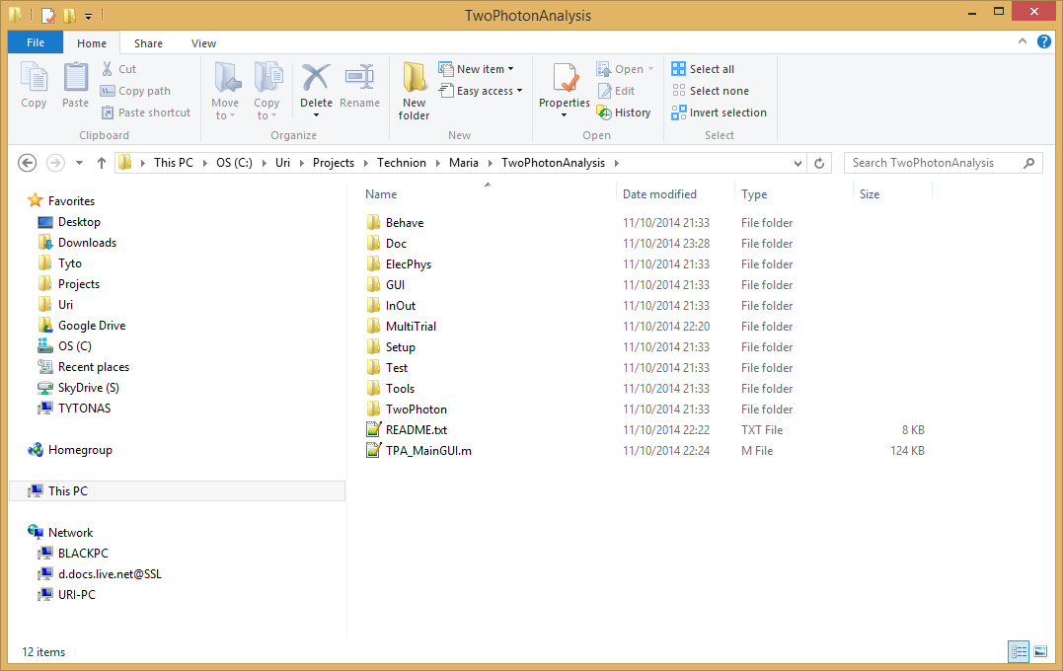

Figure : Directories description

Directories:

1. Behave – files related to behavior
2. Doc – this manual
3. ElecPhys - future integration with electro physiology system
4. GUI - files that provide support for GUI
5. InOut - import and export information to/from the SW
6. MultiTrial - files that operate on multiple trials
7. Setup - configuration parameters and session save info
8. Test - test code
9. TwoPhoton - two photon processing and analysis functions

# Revision History

|  |  |  |  |
| --- | --- | --- | --- |
| **Vers.Rev** | **Description/Rationale** | **Date** | **Author** |
|  |  |  |  |
|  |  |  |  |
| 19.23 | Delay Map is added | 17.02.15 | UD |
| 19.21 | dF/F image display, ROI adjustment, Multitrial additions | 27.01.15 | UD |
| 19.15 | Image STD and DFF added. Functionality of MultiTrial Explore | 18.12.14 | UD |
| 19.08 | Changing dir names. Adding global Event assignment. | 11.10.14 | UD |
| 19.07 | Testing different bugs and data flows. | 03.10.14 | UD |
| 19.06 | Integrating with new Jaaba mice code. | 24.09.14 | UD |
| 19.04 | ROI selection from Menu by name is working. | 12.08.14 | UD |
| 19.03 | Description of the roi objects and other SW options | 10.08.14 | UD |
| 19.02 | Updating for the latest options | 05.08.14 | UD |
| 18.10 | Updating back in Janelia. Data structure images | 08.07.14 | UD |
| 18.06 | Move TwoPhoton ROI command | 15.05.14 | UD |
| 18.04 | Adding Jaaba Excel import, Export to Excel | 29.04.14 | UD |
| 18.03 | Renamed to support ElectroPhysiology | 25.04.14 | UD |
| 17.09 | dF/F with 10% min averaging is given | 07.04.14 | UD |
| 17.08 | Major bug in ROI fixed. Requires previous ROI data rerun | 05.04.14 | UD |
| 17.05 | Improving with Liora | 25.03.14 | UD |
| 17.04 | Multi Trial Registration – working and testing | 23.03.14 | UD |
| 17.03 | Multi Trial Registration | 13.03.14 | UD |
| 17.02 | ROI projection for al trials | 10.03.14 | UD |
| 17.01 | Explorer updated | 06.03.14 | UD |
| 17.00 | Describes new SW from Janelia visit | 05.02.14 | UD |
| 14.00 | Adopted for Janelia IF | 25.12.13 | UD |
| 13.13 | Created | 20.12.13 | UD |